Here are your instructions on how to take your hair sample

Important

You will need at least 6 cm of hair to provide a sample.

Samples are taken from the back of the head. You only need to provide a small amount and you will not be left with a bald patch.

​

*Please include your mTurk ID with your samples.

IMPORTANT
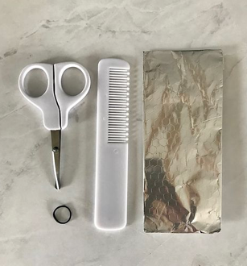
The sample will need to be at least 3mm wide and 6cm long.
​To provide a hair sample you will need:

1 x scissors,
1 x comb,
1 x piece of string, hair band, rubber band, or thread
1 x tinfoil for the storage of your samples.

Step 1
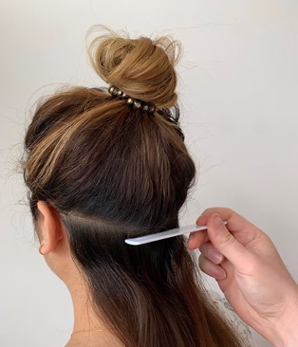
If you have long hair then tie your hair up in a bun. This will make it easier for you to provide a sample.

Please take a sample from the 'cranial bone' area of your head. This is where you feel the shape of your head change into a pronounced bulge. Please only take a sample from the area of the head indicated here.
​
Hair samples can be taken by members of your household. Please do not ask others due to the guidance regarding self-isolation.

Step 2
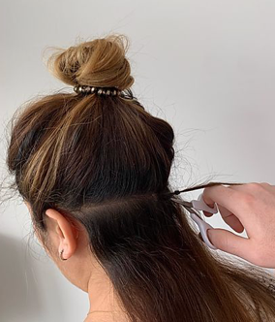
Next, separate the hair (approx. half a pencil width) using a hairband.
Important - keep the hairband on the root end of the hair sample.
Make sure that you cut the hair in front of the hair band as close to the scalp as possible.

Please remember to leave your string/hair band attached so that it is clear which is the root end of the hair sample.

Step 3

Place your hair sample in tinfoil ensuring the hair band is still attached.

Fold the tinfoil into an envelope to keep your sample secure.

Please attach your research ID and date to each sample. Please mark the root end using an arrow.

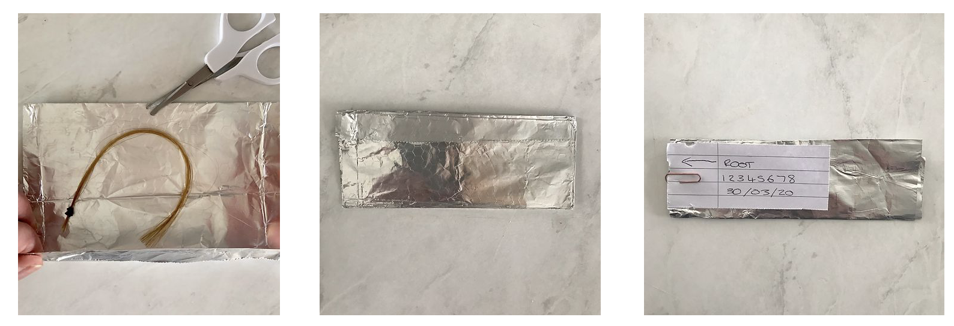

How to send your samples to us
Step 1
Please add your mTurk ID, the date you took your sample, and mark the root end with an arrow.

Step 2
Please enclose your hair sample stored in the tin foil in your envelope and make sure your envelope is sealed.

Step 3
Fill out your envelope with the following information. Do not include a return address or your contact information.

Rapunzel Study
2450 Riverside Ave.
F282
Minneapolis, MN 55454

Finally, add your stamp and drop off at your post-office.

FAQs

About This Study
​
Q: Why do you need samples of my hair?
​
A: We hope to analyze cortisol levels using these hair samples. It can tell us whether any emotional stress you have experienced has affected you physically in ways which could affect your health.

Q: What will happen to the sample I provide?
​
A: Once the hair samples have arrived with us, we will first store them in a safe place for analysis. To extract cortisol from hair, your samples will be assayed following a standard laboratory protocol. We will use your hair samples to extract only cortisol. You will not be identified during the analysis phase.

Q: Are you going to analyze something else with my hair?
​
A: No. We will use your hair samples to only measure cortisol levels.

Q: I am concerned about the information you get from my hair samples. Are you going to analyze my DNA or something else from them?
​
A: No. Your hair samples will only be used to measure cortisol levels. We will follow a standard laboratory protocol.

Taking Your Hair Samples
​​
Q: Is a single hair or a lock (group) of hair needed?
​
A: For each hair sample, it should be a lock (group) of hair which is at least 3mm wide (about the width of half a pencil) and 6cm long. This amount will enable us to look at levels of the hormone over a 6-month period.

Q: Do I need to wash my hair before taking the sample?
​
A: No, you don’t need to wash your hair before taking any hair samples. When we analyze the hair samples, they will be washed as part of our standard procedure.

Q: What if I dyed my hair? Can I still take the hair samples?
​
A: Yes, you can still take part in the study if you have dyed your hair. Hair washing frequency and hair treatment have only minor effects on cortisol in hair.

Q: I have plenty of grey hair, can I still take part?
​
A: Yes, you can still take part. We can extract cortisol from grey hair.

Q: I have plenty of grey hair, Do I need to pick them out from the samples?
​
A: No. You don’t need to take the grey hair out. We can extract cortisol from grey hair.

Q: Where shall I take the hair sample?
​
A: The hair sample should be taken from the back of your head, the ‘cranial bone’ area where you feel the shape of your head change into a pronounced bulge (i.e., the bumpy bit at the back). This is the area from where we can measure cortisol most reliably.

Q: If I don’t have enough hair at the back, can I take the samples from other area?
​
A: Unfortunately, we cannot accept hair samples taken from places other than the ‘cranial bone’ area. This is the area from where we can measure cortisol most reliably.

Q: My hair is long or at least longer than 6cm, do I need to cut my hair from the tip when taking the sample?
​
A: No. Please do not cut your hair from the tip or into pieces while taking the hair sample.
​
Q: Do you need the root of the hair?
​
A: No. For the analysis of cortisol in hair, we do not need the root of the hair. Please do not pull your hair out!

The information from this guide was taken from https://www.covidstressstudy.com

